

Software Engineering Department

Capstone Project – Phase B (61999)

Predictive Failure Detection in CT Systems

26-1-D-31

Students:
Anat Rutman
Iris Kanter

Advisor:
Dr. Reuven Cohen

Co-Advisor from Philips:
Michael Bikman

Link to GitHub**:
https://github.com/philips-internal/DmsCTInnovation/tree/main/service_event_prediction
https://github.com/anatrut/AI-Based-Analysis-and-Fault-Prediction-System-for-CT-Scanners-Project.git

**Because this project uses Philips scanner logs, the source code and related materials are stored in a private Philips repository. Access permissions are granted manually. To get access, please contact team member – Anat Rutman (Mail: Anat.Rutman@e.braude.ac.il)

Contents
Abstract 4
1. Introduction 4
2. The Project 5
2.1. System Platform 5
2.1.1. Activity Diagram 5
2.1.2. User Interface 6
2.1.3. Project Package Diagram 7
2.2. CT Fault Prediction Using Machine Learning 9
2.3. Log Processing and Feature Extraction 9
2.4. Prediction Model 10
2.5. Risk Output and Decision Support 10
2.6. Data Scope and Model Inputs 10
3. Solution Architecture and Development Process 11
3.1. Overall System Pipeline 11
3.2. Data Pipeline and Preparation 13
3.3. Model Evolution 14
3.4. Current TBPTT-Based Model 15
3.5. Inference, Reports, and Dashboard 17
4. Results and Discussion 18
4.1. Baseline Model Results 18
4.2. Sliding-Window LSTM Results 18
4.3. TBPTT Model Results and Current Status 19
4.4. Comparison Between the Main Approaches 20
4.5. Final Discussion 20
5. Constraints and challenges 21
5.1. Data size 21
5.2. Failure-to-Healthy-Time Ratio 21
5.3. Computational Resource Requirements 21
5.4. Increasing Model Training Time 21
5.5. Preserving Critical Information 22
5.6. Model Interpretability 22
6. Summary and Future Work 22
7. Maintenance guide 24
Prerequisites 24
Directory Layout 24
Step 0 – Manual Artifacts Setup 25
1. `LSTM/artifacts/event_type_include.json` 25
2. `C:\DMSInnovation_Data\Complaints_data\DMS_Complaints.csv` 25
Step 1 – Configure Data Extraction (Vertica) 25
Environment variable overrides (optional): 25
Set Vertica credentials before running extraction 26
Step 2 – Run Data Extraction 26
Step 3 – Configure the LSTM Pipeline 26
Data Paths (usually auto-discovered, but verify): 26
Pipeline Flags (set to `True` for a full from-scratch run): 26
Force-retrain flags (set to `True` to overwrite existing checkpoints): 27
Device Configuration: 27
Training Hyperparameters (usually fine as defaults): 27
Step 4 – Run the Full Pipeline 27
Where Things Are Located 28
Logs 28
Model Checkpoints 28
Data Artifacts 28
Reports & Plots 28
8. User guide 29
Overview 29
Step 1 – Locate the Inference Results 29
Step 2 – Copy the File to the Dashboard 29
File naming convention 30
Step 3 – Start the Dashboard 30
Option A: Using the batch file (easiest) 30
Option B: From the terminal 30
Step 4 – Open the Dashboard in Your Browser 30
Step 5 – Stop the Dashboard 30

Abstract
This project focuses on predictive maintenance for CT scanners from operational logs using machine learning methods. CT scanners continuously generate large volumes of time-stamped operational data, including software events, hardware-related messages, calibration activity, scan-related information, warning indications, and service-related records. Because these logs are large, heterogeneous, and difficult to inspect manually, it is challenging to identify early signs of developing problems before a failure occurs.

The goal of the project is to transform raw CT scanner logs into a predictive maintenance system that can estimate future scanner failures. The system extracts logs from a Vertica database, preprocesses and organizes the data by scanner and time, builds machine-learning-ready representations, trains several models, and produces prediction reports that can be displayed in a dashboard. The main prediction task is to estimate the time for a future maintenance-relevant event, and also the event-type.

The project was developed in several stages. First, classical machine learning models, including Random Forest classification, Random Forest regression, and Isolation Forest anomaly detection, were used as baselines. Next, a sequence of LSTM-based models were used, as timing sequence of the scanner events contain important predictive information. The current development direction is based on Truncated Backpropagation Through Time (TBPTT) model, which allows long chronological scanner histories to be processed more efficiently. The final system connects backend model outputs to a JSON-based scanner report and a dashboard interface, supporting service engineers and R&D users in identifying scanners that may require attention.
Overall, the results show that CT scanner logs contain useful predictive signals, with the TBPTT-based approach providing a scalable direction that improves true-event detection while still requiring further work to reduce false positives and improve event-type classification.

Introduction
Modern CT scanners are complex medical imaging systems that generate large amounts of operational data during routine use. These logs describe many aspects of scanner behavior, including software activity, scan-related processes, calibration events, warnings, system messages, hardware-related indications, and service-related activity. In many cases, these logs may contain early signs of abnormal behavior before a maintenance event occurs. However, because the data is large, irregular, and distributed across multiple log types, manual analysis is not practical as a regular monitoring solution.

In current practice, scanner logs are often used after a problem occurs, as part of troubleshooting or service investigation. This means that valuable information may be available before the event, but it is not always used early enough to support proactive maintenance. A predictive maintenance system can help close this gap by learning from historical scanner behavior and identifying patterns that may indicate future service-related or fault-related events.

This project addresses the problem by developing a machine-learning-based pipeline for CT scanner fault prediction. The system receives historical operational logs, preprocesses them into structured and chronological representations, trains predictive models, and generates scanner-level reports. The main objective is not only to classify whether a scanner is problematic, but also to estimate when a future event may occur. This timing-based view is important because maintenance decisions depend on how soon a possible issue is expected.

The practical implementation of the project includes several pipelined components: data extraction, preprocessing, feature representation, model training, inference, evaluation, output reporting, and dashboard visualization. The project purpose is to support service engineers, R&D teams, and operational users by providing earlier warning indications and helping in understanding the scanner behavior over time.

The Project
The CT Fault Prediction project is an AI-based predictive maintenance system for Computed Tomography (CT) scanners. The system is designed to analyze large volumes of operational logs and identify patterns that may appear before future service-related or maintenance-relevant events. Instead of using logs only after a failure or service event occurs, the project attempts to use historical behavior to estimate future risk.

The system is built around the idea that scanner behavior changes over time. A single log row may not be meaningful by itself, but repeated warnings, unusual event frequencies, changes in numeric parameters, irregular timing patterns, or combinations of events may indicate a developing issue. Machine learning can be used to learn such patterns from historical data and produce predictions for future time periods.

The output of the system is intended to support human decision-making. The model does not replace service engineers or R&D investigation. Instead, it provides a scanner-level prediction that can help users prioritize which scanners should be inspected, monitored, or investigated further.

System Platform
The platform receives CT scanner logs, processes them in the backend pipeline, applies machine learning models, and produces scanner-level prediction outputs. These outputs include predicted time to issue, predicted issue type, scanner status, and explanatory comments. The dashboard then presents this information in a structured interface that helps users identify scanners that may require attention.

Activity Diagram
The process begins when CT scanners generate operational logs – errors, voltages, temperatures, calibration data, and more – which are extracted from the Vertica database. The system normalizes these logs, attaches ground-truth service event labels, and converts each log type into compact latent vectors using trained autoencoders.
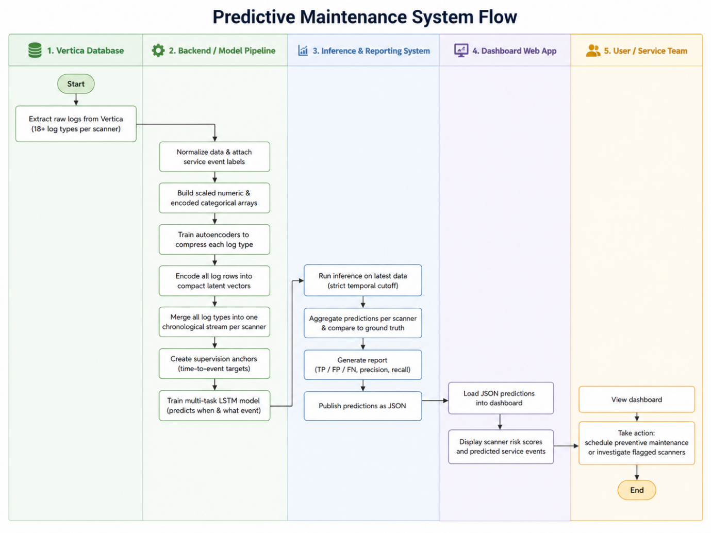
All the encoded log types are then merged into a single chronological stream per scanner, with supervision anchors marking time-to-event targets. The multi-task LSTM model processes each stream and predicts both when and what type of service event is likely to occur. The predictions are scored against actual outcomes, and the results are presented to the user through a web dashboard showing per-scanner risk levels and recommended preventive maintenance actions.
Figure 1 – Activity Diagram

User Interface
The user interface is intended to provide a clear operational view of scanner predictions. The dashboard displays scanner-level information such as scanner ID, location, predicted issue type, days until issue, current status, and comments.

The dashboard is designed mainly for technical users, such as service engineers and R&D engineers. These users need a fast way to identify scanners with upcoming predicted issues, filter scanner lists, and inspect relevant prediction information. The dashboard therefore serves as the presentation layer of the system, connecting machine learning results to practical maintenance support.

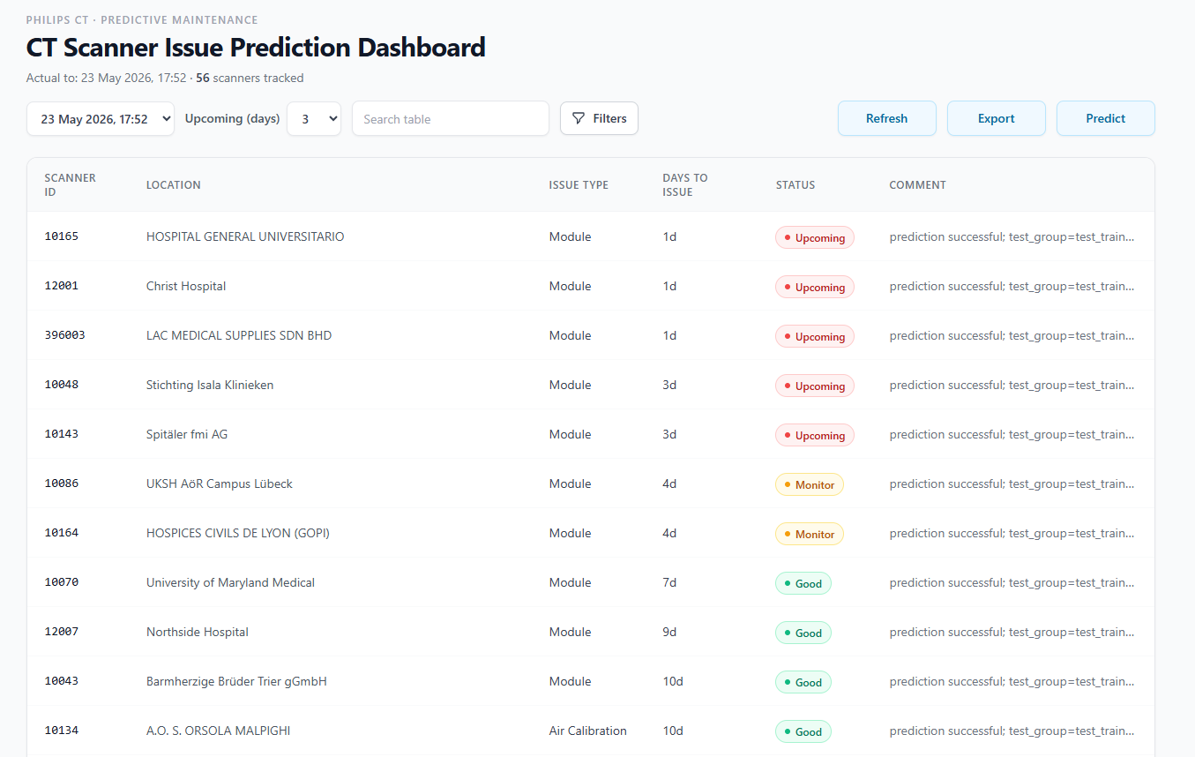
Figure 2 – User Interface

Project Package Diagram
The package diagram presents the major components of the service event prediction project and the relationships between them. The system is divided into nine logical packages: data ingestion from Vertica, centralized configuration, pipeline orchestration, data preparation and normalization, offline autoencoder-based encoding, TBPTT stream construction, LSTM model training, future-window inference, and a React-based monitoring dashboard. This separation maintains modularity across the full ML lifecycle – from raw CT scanner log extraction through multi-task predictive modeling to end-user alerting – and allows future expansion or replacement of individual stages without redesigning the pipeline.

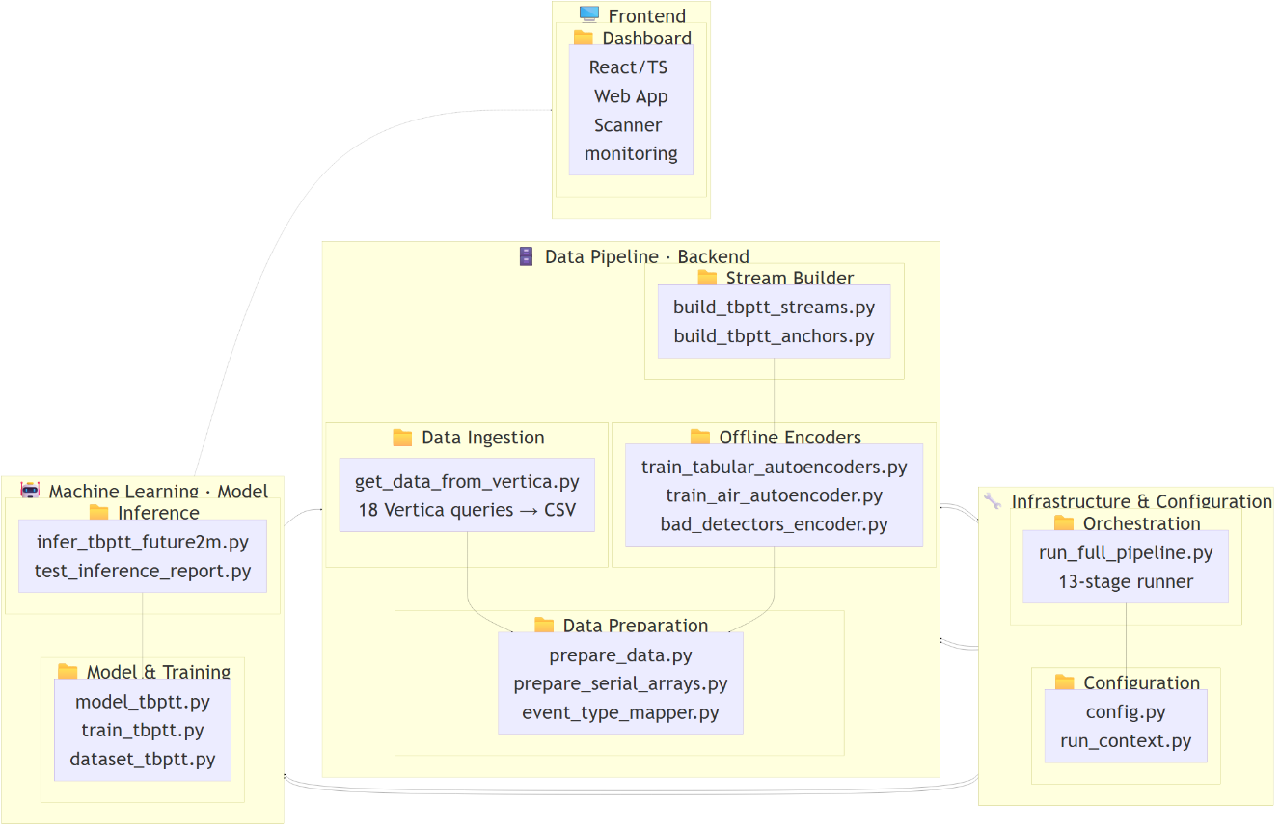
Infrastructure & Configuration
Figure 3 – Package Diagram
Configuration – Defines hyperparameters, file paths, run directories, and stage logging settings.
Orchestration – Coordinates the 13-stage pipeline with CLI stage selection.

Data Pipeline (Backend)
Data Ingestion – Extracts 18 log types from Vertica DB and exports them as per-serial CSV files.
Data Preparation – Normalizes CSVs to Parquet, infers feature schemas, and builds per-serial NumPy arrays.
Offline Encoders – Compresses tabular rows, AIR calibration frames, and bad detector data into latent vector embeddings using autoencoders.
Stream Builder – Merges all encoded logs into unified TBPTT streams and builds anchor supervision tables.

Machine Learning (Model)
Model & Training – Implements the LSTM + attention multi-head model with TBPTT chunked training.
Inference – Generates future-2-month predictions and outputs JSON scanner report.

Frontend
Dashboard – React/TypeScript web UI displaying scanner status, risk filtering, and reading JSON inference reports.

CT Fault Prediction Using Machine Learning
The machine learning component is responsible for transforming recent scanner behavior into a predictive risk estimate. Unlike traditional rule-based monitoring, which is usually used by service, or operational teams and depends on manually defined thresholds, the proposed system learns from historical data. The model uses scanner behavior to learn patterns that may indicate future risk.

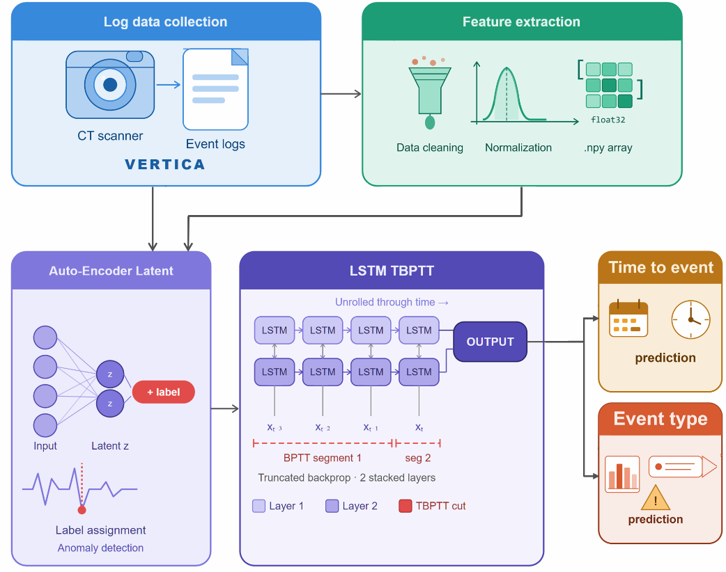
The project does not rely only on explicit fault messages. In many real systems, explicit fault labels may be incomplete, inconsistent, or available only after investigation. Therefore, the project also uses maintenance-relevant events and service-related records as supervised targets. This makes the system more realistic because it learns from operational outcomes rather than requiring perfect root-cause labels for every case.
Figure 4 – System Architecture

Log Processing and Feature Extraction
The raw input data consists of CT scanner logs extracted from the Vertica, a high-performance analytical database used for storing and querying large volumes of structured data. These logs are organized by scanner serial number and log type. Each log type describes a different aspect of the scanner behavior and may contain a different set of fields. Some log types appear very frequently, while others occur only during specific scanner states or service-related activities.

Before machine learning can be applied, the logs must be cleaned, standardized, and ordered chronologically. The preprocessing pipeline parses timestamps, removes invalid records, handles duplicate rows, standardizes scanner identifiers, and treats placeholder values such as -1 and NONE as missing or non-informative values. This step is essential because inaccurate timestamps, corrupted rows, or inconsistent identifiers can damage the temporal structure of the data.

The project uses different data representations according to the type of model. Classical models such as Random Forest cannot directly read long sequences of raw log events, so the logs are first summarized into tabular features such as event counts, frequencies, and numeric statistics. Sequence models, such as LSTM, receive the logs in chronological order, so they can learn from the timing and order of events. In the TBPTT pipeline, each log row is first converted into a compact numeric vector, and then all rows of the scanner are arranged as one long time-ordered stream. This allows the model to process long scanner histories more efficiently while still preserving the order of events.

Prediction Model
The prediction engine receives the preprocessed representation of the scanner behavior and outputs predictions related to future maintenance-relevant events. The main output is the estimated number of days until the next maintenance event. Event type is predicted as an additional output, but timing is the most important part of the final evaluation.

Several model families were tested during the project. Random Forest with classification and regression models were used as initial baselines because they are simpler and more interpretable. Isolation Forest model was used to detect anomalous behavior in aggregated time windows. Later, the project moved to LSTM-based sequence models, because scanner logs are naturally temporal and the order of events may contain important information.

The current development direction is based on an LSTM trained with TBPTT. This approach allows the model to process long scanner histories as chronological streams while keeping memory usage and training time manageable.

Risk Output and Decision Support
The final output of the system is designed to support maintenance decisions rather than present raw model outputs only. During inference, the model generates scanner-level predictions. These predictions are saved as JSON reports. The JSON reports are used by the dashboard to present the prediction results in a user-friendly interface.

The output include the scanner ID, predicted issue type, predicted number of days until issue, the status, and a descriptive comment. The dashboard use this information to show which scanners are predicted to have upcoming issues and which scanners are currently considered lower risk.

Data Scope and Model Inputs
The dataset used in the project was extracted from CT scanner operational logs stored in a Vertica database. The experiments used 60 scanner serial numbers, 18 log types and covered the period from December 2024 to December 2025. Across the selected scanners and log sources, the extracted dataset contained approximately 80 million raw log rows. An external event table contained approximately 300 maintenance-relevant events grouped into 7 mapped event types.

The data is strongly imbalanced. Most scanner activity represents normal operation or periods far from a service event, while maintenance-relevant events are rare. This creates a difficult training problem because the model must identify weak and rare patterns inside a very large amount of normal activity.

Different model stages used different input formats. The Random Forest models used aggregated feature tables. The sliding-window LSTM used event-level windows containing categorical feature IDs, numeric values, numeric masks, and sequence lengths. The current TBPTT direction uses encoded row vectors, timestamps, log-type identifiers, and supervised anchor positions. This allows the model to process long chronological scanner histories while computing loss only at selected prediction points.

Solution Architecture and Development Process
This chapter describes both the current architecture of the CT Fault Prediction system and the main development steps that led to it. The purpose is to present the solution as one clear flow, instead of separating the system architecture from the development process and repeating similar explanations. The system is not only a machine learning model; it is an end-to-end predictive maintenance pipeline that begins with raw scanner logs and ends with dashboard-ready prediction reports.

Overall System Pipeline
The current solution is an end-to-end predictive maintenance pipeline for CT scanners. It begins with raw operational logs extracted from the Vertica database and ends with scanner-level prediction outputs that can be displayed in a dashboard interface. The purpose of the pipeline is to transform large, heterogeneous, time-stamped scanner logs into useful maintenance predictions.
The full system includes data extraction, preprocessing, feature representation, model training, inference, evaluation, report generation, and dashboard visualization. This structure is important because predictive maintenance requires more than a standalone model. The system must prepare data correctly, train and evaluate models reliably, and present the results in a way that can support real users.

The architecture can be summarized as follows:
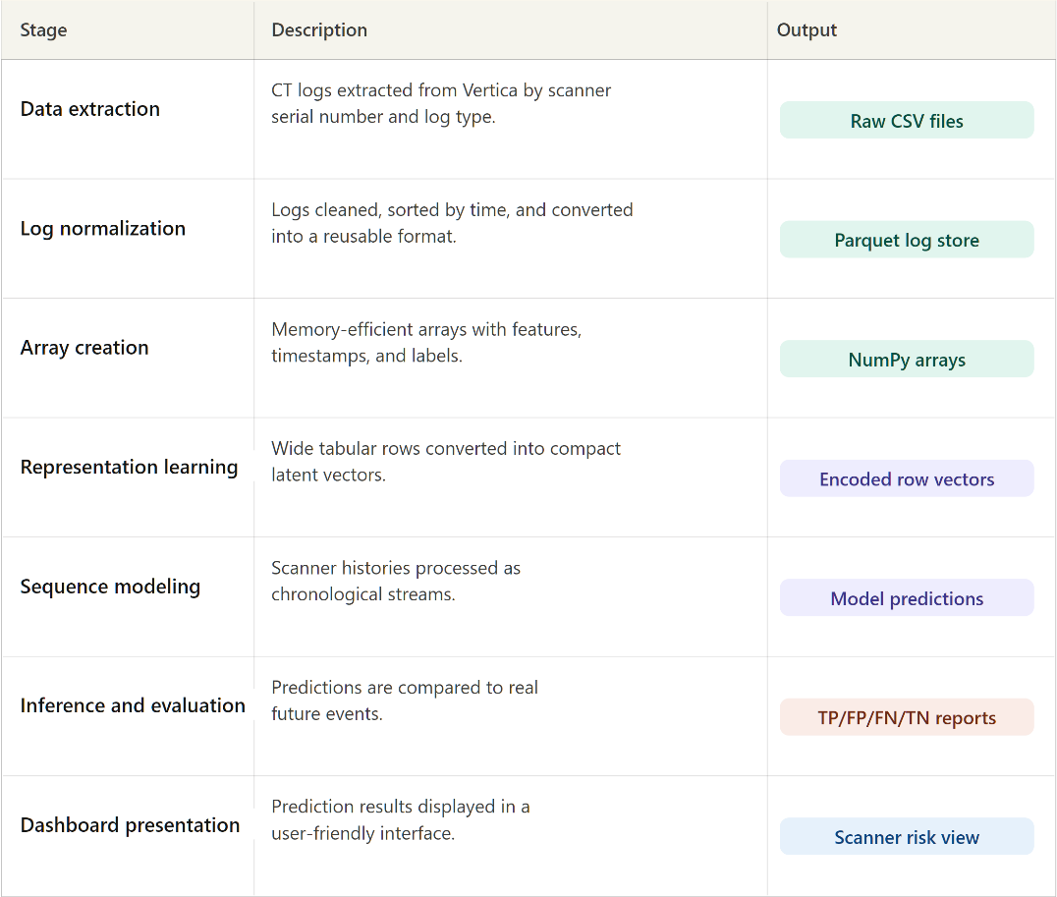
Figure 5 – Summarized Architecture

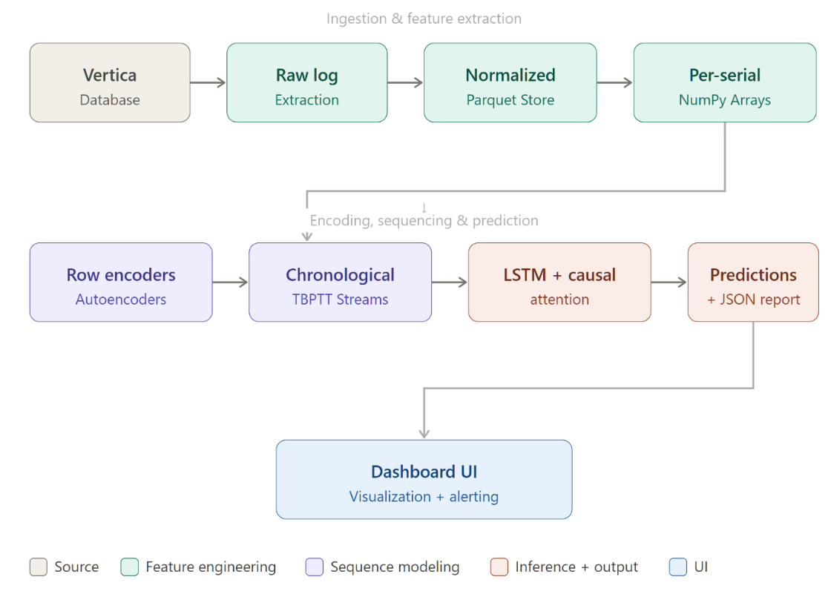
A simplified system view is:
Figure 6 – Simplified System View
The pipeline was designed to support very large scanner histories while preserving as much temporal information as possible. Since scanner logs are irregular, heterogeneous, and highly detailed, the system avoids reducing the data too early. Instead, it gradually converts raw logs into compact but time-preserving representations that can be used by sequence models.

Data Pipeline and Preparation
The data pipeline begins with CT scanner logs stored in Vertica, an analytical database used for storing and querying large volumes of structured data. The logs include different types of operational information, such as software events, hardware-related messages, scan activity, calibration information, warning indications, parameter values, and service-related records. Each row contains a timestamp and scanner identifier, which allows the system to organize scanner behavior chronologically.

The first development stage was raw data extraction. The logs were extracted using SQL queries through a Python-based pipeline. Because the raw data volume was very large, the extraction was performed in batches and stored as CSV files organized by log type and scanner serial number. This structure was important because each log source may contain different fields and may appear at different frequencies.

After extraction, the data was cleaned and normalized. This included timestamp parsing, removal of invalid rows, duplicate handling, scanner identifier normalization, and chronological sorting. Placeholder values such as -1 in numeric fields and NONE in categorical fields were treated as missing or non-informative values rather than real measurements.

A major preprocessing decision was to avoid joining all log types into one large wide table. Such a join would create a highly sparse dataset because different log sources contain different fields and do not occur at the same timestamps. Instead, the project treated logs as event streams. Each log type was processed separately and later combined chronologically by scanner and time.

After normalization, the logs were converted into a parquet log store. The parquet format creates a reusable and efficient intermediate representation that avoids repeated parsing of large raw CSV files. The normalized logs were then converted into per-serial NumPy arrays containing categorical values, numeric values, numeric masks, timestamps, labels, and log-type identifiers.

For the later sequence models, the data representation was further optimized using compact encoded row vectors. Each log row was converted into a smaller numeric representation using row-level encoders or autoencoders. These encoders were trained with both reconstruction loss and occurrence loss, so the compressed representation would preserve not only the structure of the original row but also signals related to future event prediction.

Finally, all enabled log sources were merged chronologically per scanner into a TBPTT stream. Each stream contains encoded row vectors, timestamps, and log-type identifiers. This unified time-ordered stream represents scanner behavior and can be processed efficiently by the sequence model.

Model Evolution
The modeling process developed gradually. The first models were classical machine learning baselines, which were used to verify whether the extracted logs contained predictive information. Later, the project moved toward sequence models because the timing and order of scanner events contain important predictive signals.

Before describing the current model, the following table summarizes the main model evolution:
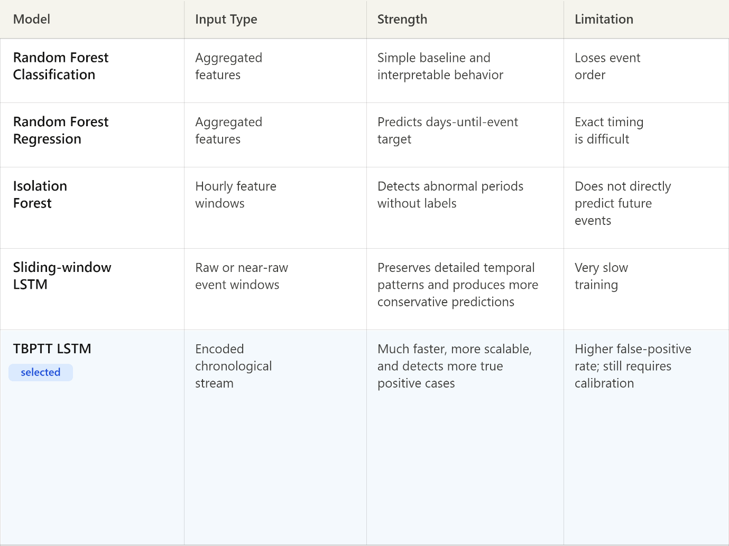
Figure 7 – Main Model Evolution

The first supervised model was a Random Forest classifier. It predicted whether a service-related event would occur within a predefined future horizon. The continuous days-until-event target was converted into a binary label. For example, if the next event occurred within 14 days, the sample was labeled positive; otherwise, it was labeled negative. This model was useful as an early baseline because Random Forests are robust, relatively easy to train, and can provide some interpretability through feature importance.

A Random Forest regression model was also implemented to predict the number of days until the next event. This task was more difficult because the model had to predict exact timing rather than only decide whether an event occurred within a horizon. The regression model confirmed that the days-until-event target contained some learnable structure, but it also showed that exact timing prediction is noisy and difficult.

In addition, Isolation Forest anomaly detection was tested on aggregated one-hour time windows. This model detected unusual scanner behavior without requiring supervised labels. It provided another view of abnormal periods, but because it was not directly trained to predict future events, it was not used as the main final prediction approach.

After the baseline experiments, the project moved toward sequence modeling. Aggregated features lose detailed temporal information, while scanner logs contain many events whose order, density, and timing may carry important predictive signals. The first main sequence model was a sliding-window LSTM. Each sample represented a recent time window before a prediction anchor. This model preserved event order and showed that sequential event information is valuable for the task. However, it was computationally expensive because overlapping windows caused the same scanner rows to be processed many times. Training one epoch required approximately 5-6 hours, making experimentation slow.

This limitation motivated the transition to the current TBPTT-based approach.

Current TBPTT-Based Model
The current model direction is based on an LSTM trained using Truncated Backpropagation Through Time. Instead of training on many overlapping windows, TBPTT processes each scanner as a chronological stream divided into chunks. The LSTM hidden state is carried from one chunk to the next, while gradients are detached between chunks. This allows the model to use long scanner context without backpropagating through the entire history.

The TBPTT approach reduced training time from approximately 5-6 hours per epoch to approximately 30 minutes per epoch. This was a major engineering improvement because it allowed more experiments to be tested in a practical amount of time.

The model receives a chronological stream of encoded scanner rows. Each row contains a compact vector representation of the original log entry and a log-type identifier. The log-type identifier is passed through an embedding layer so the model can distinguish between different sources of scanner information. The encoded row vector and log-type embedding are combined and passed into the sequence model.

At selected anchor positions, the model produces supervised predictions. These anchors represent points in time where the model is asked to estimate future scanner behavior. Around each anchor, local causal attention is applied. This allows the model to focus on recent relevant events before the prediction point, but not on future events. This prevents information leakage and keeps inference realistic.

The current model outputs are:

Output Head | What It Predicts | Why It's Needed
Hazard Head | Probability of an event occurring in each discrete future time bin (e.g., bin 0 = days 0–7, bin 1 = days 7–14, etc.) | Primary timing prediction – models when an event will happen as a discrete hazard function, giving a full probability distribution over future time windows
Occurrence Head | Binary prediction of whether any event occurs within each horizon window (7/14/30/60 days) | Answers the yes/no question "will something happen within X days?" – useful for alerting and threshold-based decision making
Event Type Head | Which type of event will occur, predicted separately for each horizon | Answers what will happen – enables targeted preventive action based on the predicted failure/event category
Days Head | Scalar regression predicting days-to-next-event | Auxiliary signal that provides a single continuous estimate of timing; acts as a regularizer and gives an interpretable "days remaining" value
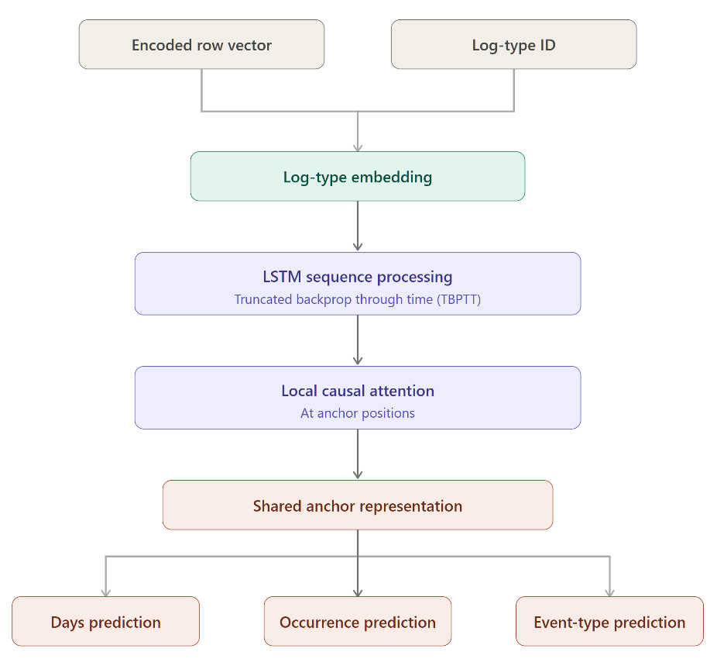
Figure 8 – Model Outputs
The hazard head is the main timing mechanism because the final operational evaluation is based mainly on when an event is expected to occur. The occurrence head helps the model learn whether an event is approaching within selected horizons. The event-type head gives additional information about the possible issue category, but it is secondary to timing. The days head provides an additional continuous estimate that can support interpretation.

At the current stage, TBPTT is the chosen development direction because it is much more scalable than the sliding-window approach and detects more true positive cases. Its main limitation is a higher false-positive rate, so the main future improvement is to reduce unnecessary alerts while preserving the improved true-event detection.

Inference, Reports, and Dashboard
After training, the model is used for inference on recent scanner history. During inference, the system generates scanner-level predictions, including predicted event timing, expected event type, and alert-related outputs. Several recent predictions may be aggregated to create a more stable scanner-level result.

The final evaluation is based mainly on timing. A prediction is considered correct if a real future event occurs inside the allowed timing window around the predicted event date:

prediction date - 15 days <= true event date <= prediction date + 30 days

If a true event appears inside this window, the prediction is counted as a true positive. If the model predicts an issue but no matching event appears inside the allowed window, it is counted as a false positive. If a real event occurs but the model does not report it correctly, it is counted as a false negative. If no event occurs and the model does not report an issue, it is counted as a true negative.

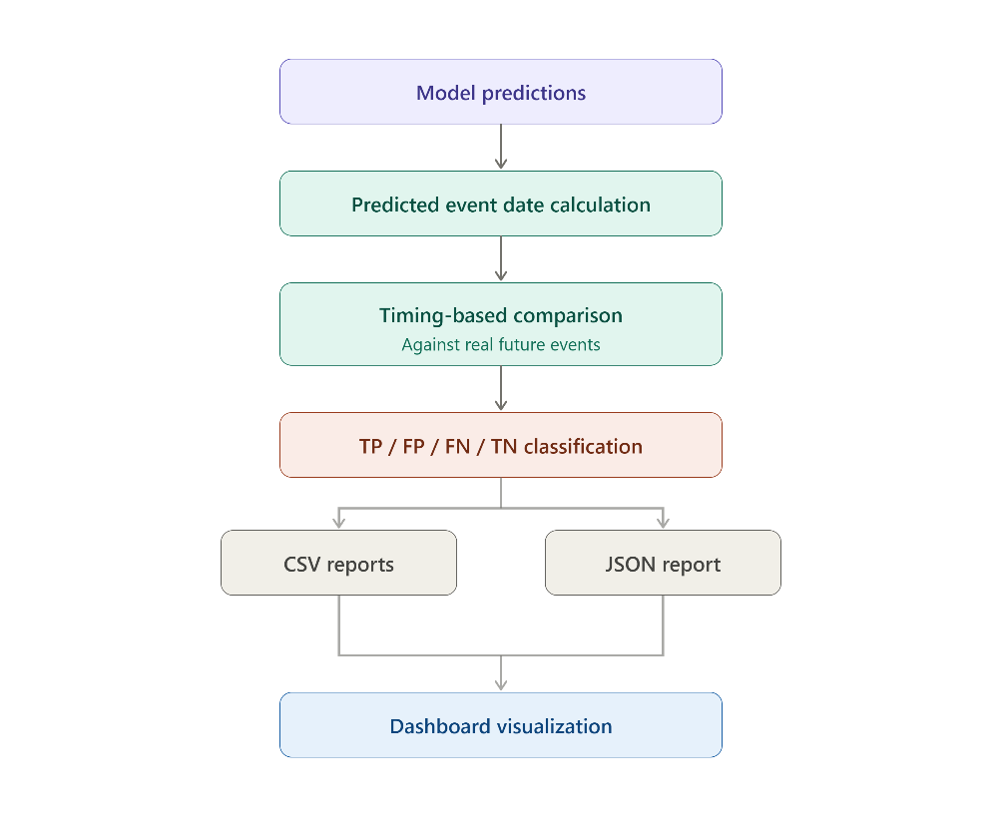
The current output flow can be summarized as:
Figure 9 – Current Output Flow
After inference, the system generates output files that summarize scanner predictions. These include prediction tables, true-event comparison tables, detailed TP/FP/FN/TN reports, and a JSON scanner report. The JSON report is especially important because it acts as the connection between the backend model and the dashboard.
The dashboard was developed as the presentation layer of the system. It reads the generated JSON report and displays scanner-level predictions in a clear interface. Users can view scanner ID, location, issue type, days until issue, status, and comments. This makes the output easier to understand and supports practical maintenance prioritization.
This stage is important because the project is not only about model training. A predictive maintenance system must also present results in a form that users can inspect and act on. The dashboard therefore connects the machine learning pipeline to the operational use case.

Results and Discussion
This chapter presents the main experimental results and discusses their meaning. The project was developed through several modeling stages, beginning with classical machine learning baselines and progressing toward sequence-based neural models. Each stage contributed a different insight into the prediction task.

Baseline Model Results
The first experimental results were obtained using Random Forest classification and regression. These models were trained on engineered feature representations instead of raw event sequences. Their purpose was to verify whether the extracted scanner logs contained measurable predictive information.

The Random Forest classifier produced encouraging early results in a one-scanner setup. For a 14-day prediction horizon, the model achieved 82% accuracy, 85% precision, 82% recall, and an F1-score of 0.83. This showed that engineered features contained useful information related to upcoming service events.

However, these results should be interpreted carefully. The training, validation, and test data were taken from the same scanner timeline. Therefore, the setup was easier than a true future-based or unseen-scanner evaluation. The result is useful as an early internal baseline, but it should not be presented as final production performance.

The Random Forest regressor achieved an example MAE of 8 days, RMSE of 14 days, and R² score of 0.42. This confirmed that the days-until-event target had some learnable structure, but it also showed that exact timing prediction is much harder than binary horizon classification.

Sliding-Window LSTM Results
The sliding-window LSTM showed the best learning behavior so far. Unlike Random Forest models, it used chronological event windows and preserved more temporal detail. This allowed it to learn from event order, event density, and changes in scanner behavior over time.

The main strength of this model was its ability to learn from raw or near-raw sequential information. This demonstrated that sequence modeling is a promising direction for CT scanner fault prediction.

However, the main limitation was training time. Because the windows overlapped, the same rows were processed repeatedly. One epoch required approximately 5-6 hours. This made the model difficult to tune and limited the number of experiments that could be performed.

TBPTT Model Results and Current Status
The TBPTT model was introduced to reduce the high training cost of the sliding-window LSTM. From a runtime perspective, this change was successful. Epoch time was reduced from approximately 5-6 hours to approximately 30 minutes. This made the pipeline much more practical for experimentation.

At the current stage, the TBPTT model shows a different prediction behavior than the slower sliding-window LSTM. While the sliding-window LSTM produced fewer false positives, the TBPTT model detected more true positive cases, which is more important for the operational goal of early issue detection. This means that the TBPTT approach is more sensitive to future service-related events, but it still requires further calibration to reduce unnecessary alerts.

Therefore, TBPTT should be interpreted as the current preferred scalable framework. It solves the runtime problem, increases the number of detected true events, and enables continued experimentation. The main remaining challenge is not only improving learning quality, but balancing sensitivity and precision: keeping the higher true-positive detection while reducing false positives through better thresholds, representation learning, supervision strategy, and loss design.

To better understand the tradeoff between the earlier raw-data sequence model and the current compressed-data TBPTT model, the main results are summarized in the table below. The raw-data model was more conservative and produced fewer false positives, but it missed many real events and required long training time. The compressed-data TBPTT model was much faster and detected more true events, which is more important for the early-warning goal of the project, but it also produced more false positives and therefore requires further calibration.

Metric | Raw-data sequence model | Compressed-data TBPTT model
Accuracy | 80% | 45%
Recall | 30% | 70%
Faults found | 4/13 | 9/13
False positives | Low | Higher
Training time | 6 hours per epoch | 30 minutes per epoch
Tuning and experiments | Not practical | Practical
Main finding | Conservative, but misses many faults | Detects most real faults, but needs FP reduction
The table shows that accuracy alone is not sufficient for evaluating this project. Although the raw-data model achieved higher accuracy, it detected only 4 out of 13 real faults. The compressed-data TBPTT model had lower accuracy because it produced more false positives, but it detected 9 out of 13 real faults. Since the main goal of the system is early detection of future scanner issues, the higher recall and larger number of detected faults make the TBPTT model the preferred current direction. The main remaining challenge is to reduce false positives while preserving the improved true-positive detection.

Comparison Between the Main Approaches
The sliding-window LSTM and the TBPTT model represent two different points in the tradeoff between predictive performance and experimental efficiency. The sliding-window LSTM learned useful temporal patterns and produced more conservative predictions, with fewer false positives. However, it required approximately 5-6 hours per epoch, making it expensive to tune and difficult to use for repeated experimentation. The TBPTT model, in contrast, trains much faster, requiring approximately 30 minutes per epoch, and detects more true positive cases. Its main drawback is a higher number of false positives, meaning that the model is more sensitive but still needs better calibration and false-alert reduction.

Because the main project requirement is not only to obtain one good model, but also to develop a system that can be improved through experimentation, the TBPTT direction was selected as the current development path. A model that trains in 30 minutes per epoch allows many more experiments to be performed: alternative input representations, loss functions, anchor strategies, occurrence objectives, hazard bins, and attention mechanisms can be tested and compared. This makes TBPTT more suitable for the current research and development stage, even though its predictive quality still requires improvement.

The slower sliding-window LSTM remains an important reference model. It proves that the data contains useful sequential signal and that the prediction task is learnable when enough event-level information is preserved. The goal of the ongoing TBPTT work is therefore not to replace a weak model with a fast one, but to transfer the learning strength of the sliding-window approach into a more scalable training framework. In other words, the sliding-window LSTM serves as the performance target, while TBPTT serves as the practical architecture for continued development.

Final Discussion
The project results show that CT scanner logs contain useful predictive information, but the problem is difficult. The dataset is large, noisy, heterogeneous, and highly imbalanced. Most scanner activity is normal, while service-related events are rare. This makes it difficult for models to learn reliable near-event patterns.

The Random Forest baselines were useful because they confirmed that the problem is learnable to some degree. However, their aggregated features removed important temporal information. The sliding-window LSTM showed that sequence models are better suited to this task, but its training time was too high. The TBPTT model made training much faster and therefore became the current direction.

The main conclusion is that the project should continue with the TBPTT-based architecture as the preferred current direction. Compared with the slower sliding-window LSTM, TBPTT is much more practical to train and detects more true events, which better supports the goal of early warning. The next development focus should be reducing false positives while preserving the improved true-positive detection.

Constraints and challenges

Data size
One of the main challenges was the very large amount of data generated by CT scanners. The dataset contained approximately 80 million raw log rows across 60 scanner serial numbers. This required careful handling during extraction, preprocessing, storage, and training.

The solution addressed this challenge through batch extraction, parquet storage, memory-efficient NumPy arrays, encoded row representations, and TBPTT training. These methods allowed the project to process large scanner histories without loading all data into memory at once.

Failure-to-Healthy-Time Ratio
The dataset is highly imbalanced because scanner failures or service-related events are rare compared with normal operation. Most examples are far from an event, while event-near examples are much less frequent. This makes it difficult for the model to learn early warning patterns.

This challenge affects both occurrence prediction and event-type classification. The model may become biased toward normal behavior or dominant event types. To address this, the project considered class weighting, event-near supervision, occurrence objectives, and improvements such as hazard-based timing prediction.

Computational Resource Requirements
Training models on large CT scanner histories requires significant computational resources. Deep sequence models are especially demanding because they must process many events over time. Long windows can increase GPU memory usage, and large datasets can make training slow.

The project addressed this challenge by moving from overlapping sliding windows to TBPTT. This reduced repeated computation and improved training efficiency. However, computational cost remains an important constraint because many experiments are needed to tune the model effectively.

Increasing Model Training Time
As more logs were included, model training time increased. The sliding-window LSTM became difficult to use because one epoch required approximately 5-6 hours. This limited experimentation and made it harder to test different model configurations.

TBPTT reduced this problem by processing chronological scanner streams in chunks. This reduced epoch time to approximately 30 minutes and made the system more practical for continued development.

Preserving Critical Information
Another challenge was reducing data size without losing important predictive information. Scanner logs contain many details, and even rare or low-frequency events may be important before failures. Aggressive aggregation or compression can remove these signals.

This challenge appeared clearly in the transition from raw event windows to encoded TBPTT streams. Compact representations are useful for speed, but they must still preserve information related to future events. To address this, the row-encoding stage was improved by adding an occurrence-prediction objective in addition to the reconstruction objective. In this multi-task representation approach, the encoder is not trained only to reconstruct the original log row, but also to preserve signals that help predict whether an event may occur within future horizons. This makes the compressed representation more aligned with the final prediction task while still keeping the training pipeline efficient.

Model Interpretability
Neural sequence models are difficult to interpret. While they can learn complex temporal patterns, it is not always clear which specific events or features caused a prediction. This can make it harder for service engineers and R&D users to trust or validate the model output.

The dashboard and detailed prediction reports partially address this challenge by showing scanner-level predictions, predicted timing, issue type, and status. However, future work should include better explanation tools, such as attention inspection, feature contribution summaries, or event-level evidence shown in the dashboard.

Summary and Future Work
The development process showed that CT scanner logs contain useful predictive information related to future service-related events. The Random Forest models provided initial baselines and confirmed that engineered log features contain predictive value. The sliding-window LSTM demonstrated the importance of preserving temporal event patterns, but its long training time made repeated experimentation difficult. The TBPTT-based model provided a more scalable direction by reducing training time significantly while detecting more true positive cases. Although this improved event detection, it also increased the number of false positives, showing that the current model is more sensitive but still requires further calibration.

The current solution is therefore a strong foundation, but it is still under refinement. The main future work is to reduce false positives while preserving the improved true-positive detection achieved by the TBPTT model. This includes better threshold calibration, improved loss design, stronger rare-event handling, and more careful balancing between recall and precision. Since the operational goal is early warning, the system should continue to prioritize detecting real future events, while gradually improving the reliability of alerts.

Additional future work should focus on improving event-type classification. Current results show that the model still has difficulty separating between different issue categories, mainly because the event-type distribution is highly imbalanced and some classes contain very few examples. Future improvements may include stronger class-balancing strategies, adjusted loss weights, improved sampling of minority event types, and richer type-aware representations. These methods can help the model distinguish event categories more reliably while keeping the main timing-based prediction task as the primary objective.

Future improvements can also be made in the dashboard and explanation layer. The dashboard can be extended to show more detailed evidence behind each prediction, such as recent suspicious events, risk trends, confidence indicators, or important time periods that influenced the model. This would make the system more useful for service engineers and R&D users, because they would not only see that a scanner was flagged, but also understand why it may require attention.

Overall, the project establishes a complete and scalable foundation for CT scanner predictive maintenance. It demonstrates a full workflow from raw operational logs to model predictions, structured reports, and dashboard visualization. The current TBPTT-based direction provides a practical path for continued development, with the main goal of improving alert reliability, reducing unnecessary false positives, and supporting earlier maintenance decisions.

Maintenance guide

Prerequisites
Python 3.12+ with CUDA-enabled PyTorch
Access to the Philips Vertica database (credentials & VPN)
Vertica CA certificate placed at `<project_root>/.vsql/root.crt` (or set `VERTICA_CA_FILE` env var)
Required Python packages: `vertica_python`, `pandas`, `torch`, `numpy`, `pyarrow`, etc.
At least one CUDA GPU (training uses `cuda:0`; inference uses `cuda:1` by default)

Directory Layout

C:\DMSInnovation_Data\ # Curated data root (auto-discovered)
├── data\
│ ├── Runs\ # All outputs: logs, plots, reports, models
│ │ └── <timestamp>\ # Flat folder – all files saved directly here
│ └── Models_new\local_model_v4_tbptt_hazard\ # Best model checkpoint
├── Complaints_data\
│ └── DMS_Complaints.csv # ⚠️ MUST BE MANUALLY PLACED
└── model_data\728333_dataset_v2\ # Dataset arrays, streams, anchors
├── arrays\<serial>\<log_type>\ # Per-serial encoded arrays
├── tbptt_streams\<serial>\ # Merged TBPTT streams
└── tbptt_anchors.parquet # Global anchor table
C:\DMSInnovation_Data\Raw_Data\ # Raw extracted data (or DMSInnovationRawData)
└── 728333_logs_clean_1y_new\ # Per-query-function folders
├── voltage_data\<serial>.csv
├── system_errors\<serial>.csv
├── air_calibration\<serial>.csv
└── ...
service_event_prediction\
├── get_data_from_vertica.py # Data extraction script (project root)
└── LSTM\
├── artifacts\ # Local artifacts (autoencoders, mappings)
│ ├── event_type_include.json # ⚠️ MUST BE MANUALLY PLACED
│ ├── air_autoencoder.pt
│ ├── bad_detectors_autoencoder.pt
│ ├── tabular_autoencoders\
│ ├── feature_schema_by_log.json
│ ├── numeric_scaler_by_log.json
│ ├── cat_mappings_by_log.json
│ ├── event_type_mapping.json
│ └── raw_event_type_mapping.json
├── config.py # All pipeline configuration
└── run_full_pipeline.py # Pipeline orchestrator

Step 0 – Manual Artifacts Setup

⚠️ IMPORTANT: Before running the pipeline, you must manually place the following files:

1. `LSTM/artifacts/event_type_include.json`
This JSON file defines which event types (from the complaints data) are included in training. Without this file, the pipeline will fail at the anchor-building stage.
Obtain this file from the team or create it based on the domain-relevant event categories in `DMS_Complaints.csv`.

2. `C:\DMSInnovation_Data\Complaints_data\DMS_Complaints.csv`
This is the external service events / complaints file that provides ground-truth labels for training.
Obtain this file from the complaints database export. The pipeline cannot generate labels without it.

Step 1 – Configure Data Extraction (Vertica)
Edit `get_data_from_vertica.py` (located at project root: `service_event_prediction/get_data_from_vertica.py`):
Parameter | Description | Where to Change
`START_DATE` | Inclusive start of extraction window | Module-level constant
`END_DATE` | Exclusive end of extraction window | Module-level constant
`OUT_DIR` | Output directory for raw CSV files | Module-level constant (default: `C:\DMSInnovation_Data\Raw_Data`)
`SYSTEM_CODE` | System identifier used in folder naming | Module-level constant (default: `728333`)
`LIMIT` / `LIMIT_AIR` | Max rows per query | Module-level constants
`serials` | Comma-separated serial numbers to extract | `if __name__ == '__main__'` block

Environment variable overrides (optional):
Env Var | Purpose
`VERTICA_HOST` | Database hostname
`VERTICA_PORT` | Database port
`VERTICA_DATABASE` | Database name
`VERTICA_USER` | Login username
`VERTICA_PASSWORD` | Login password
`VERTICA_CA_FILE` | Path to CA certificate file

Set Vertica credentials before running extraction

Set the Vertica credentials directly in `get_data_from_vertica.py` before running extraction.
In `get_data_from_vertica.py`, update these module-level variables:
VERTICA_USER = "your_code1_username"
VERTICA_PASSWORD = "your_code1_password"

Step 2 – Run Data Extraction
cd C:\Github\DmsCTInnovation\service_event_prediction
python get_data_from_vertica.py
Or with CLI overrides:
python get_data_from_vertica.py --serials "10013,10043,10048" --start-date "2024-12-01 00:00:00" --end-date "2026-01-01 00:00:00" --out-dir "C:\DMSInnovation_Data\Raw_Data"
Output: Per-serial CSV files in `<OUT_DIR>/<SYSTEM_CODE>_logs_clean_1y_new/<query_name>/<serial>.csv`
This step can take a long time depending on the number of serials and the date range.

Step 3 – Configure the LSTM Pipeline
Edit `LSTM/config.py` → `get_config()` function. Key items to review/update:

Data Paths (usually auto-discovered, but verify):
The pipeline auto-discovers `DMSInnovation_Data` by scanning drive letters.
Raw data root is auto-discovered from `DMSInnovationRawData` or via `DMS_RAW_DATA_ROOT`
env var.
If your raw extraction output is at `C:\DMSInnovation_Data\Raw_Data`, make sure the `extract_dir`
config points there (check that the folder name matches `728333_logs_clean_1y_new`).

Pipeline Flags (set to `True` for a full from-scratch run):
"run_normalize_extract": True, # Stage 1: normalize raw CSVs
"run_infer_features": True, # Stage 2: infer feature schema
"run_prepare_arrays": True, # Stage 3: build arrays
"run_train_tabular_autoencoders": True, # Stage 4: train tabular AEs
"run_train_air_autoencoder": True, # Stage 5: train AIR AE
"run_train_bad_detectors_encoder": True, # Stage 6: train bad det AE
"run_encode_tabular_rows": True, # Stage 7: encode tabular
"run_encode_air_embeddings": True, # Stage 8: encode AIR
"run_encode_bad_detectors_embeddings": True, # Stage 9: encode bad det
# Stages 10-11 (streams/anchors) always run
"run_train_model": True, # Stage 12: train LSTM
"run_inference": True, # Stage 13: run inference

Force-retrain flags (set to `True` to overwrite existing checkpoints):
"force_retrain_air_autoencoder": True,
"force_retrain_tabular_autoencoders": True,
"force_retrain_bad_detectors_autoencoder": True,
"force_reencode_air_embeddings": True,
"force_reencode_tabular_rows": True,
"force_reencode_bad_detectors_embeddings": True,
"delete_existing_arrays_before_prepare": True, # Wipe old arrays

Device Configuration:
"device": "cuda:0", # Training device
"inference_device": "cuda:1", # Inference device (change to cuda:0 if single GPU)
"air_autoencoder_device": "cuda:0",
"tabular_autoencoder_device": "cuda:0",

Training Hyperparameters (usually fine as defaults):
`epochs`: 50 (max training epochs)
`lr`: 3e-4 (learning rate)
`patience`: 15 (early stopping)
`batch_size`: 16
`tbptt_chunk_rows`: 6000

Step 4 – Run the Full Pipeline
cd C:\Github\DmsCTInnovation\service_event_prediction\LSTM
python run_full_pipeline.py
This runs all 13 stages sequentially:
normalize_extract – Convert raw CSVs to sorted/deduped normalized store
infer_features – Detect column types and build feature schemas
prepare_arrays – Build per-serial numpy arrays from normalized data
train_tabular_autoencoders – Train one autoencoder per tabular log type
train_air_autoencoder – Train convolutional autoencoder for AIR calibration frames
train_bad_detectors_encoder – Train autoencoder for bad detector binary frames
encode_tabular_rows – Encode all tabular rows to latent vectors
encode_air_embeddings – Encode AIR frames to embeddings
encode_bad_detectors_embeddings – Encode bad detector frames to embeddings
build_tbptt_streams – Merge all embeddings into chronological per-serial streams
build_tbptt_anchors – Build supervision anchor table with labels
train_model – Train the final TBPTT LSTM model
inference – Run future-window inference and generate reports

Where Things Are Located

Logs
Log Type | Location
Pipeline & stage logs | `C:\DMSInnovation_Data\data\Runs\<timestamp>\` (all `.log` files)

Model Checkpoints
Item | Location
Best LSTM model | `C:\DMSInnovation_Data\data\Models_new\local_model_v4_tbptt_hazard\best_model.pt`
Per-run model copy | `C:\DMSInnovation_Data\data\Runs\<timestamp>\`
AIR autoencoder | `LSTM\artifacts\air_autoencoder.pt`
Bad detectors AE | `LSTM\artifacts\bad_detectors_autoencoder.pt`
Tabular autoencoders | `LSTM\artifacts\tabular_autoencoders\`

Data Artifacts
Item | Location
Raw extracted CSVs | `C:\DMSInnovation_Data\Raw_Data\728333_logs_clean_1y_new\`
Normalized logs | `<raw_data_root>\728333_normalized_logs\`
Encoded arrays | `C:\DMSInnovation_Data\model_data\728333_dataset_v2\arrays\`
TBPTT streams | `C:\DMSInnovation_Data\model_data\728333_dataset_v2\tbptt_streams\`
Anchor table | `C:\DMSInnovation_Data\model_data\728333_dataset_v2\tbptt_anchors.parquet`
Feature schemas | `LSTM\artifacts\feature_schema_by_log.json`
Event type mappings | `LSTM\artifacts\event_type_mapping.json`

Reports & Plots
Item | Location
Inference reports | `C:\DMSInnovation_Data\data\Runs\<timestamp>\`
Training plots | `C:\DMSInnovation_Data\data\Runs\<timestamp>\`

User guide

Overview
After the LSTM pipeline runs inference (Stage 13), it produces a JSON report file named:
scanners_<DD_MM_YYYY_HH_MM>.json
This file contains predictions for all scanners and is consumed by the CT Scanner Dashboard web application. The dashboard displays each scanner's predicted time-to-issue, issue type, prediction status (TP/FP/TN/FN), and location.

Step 1 – Locate the Inference Results
After a pipeline run completes, the inference report is saved in the run output folder:
C:\DMSInnovation_Data\data\Runs\<timestamp>\scanners_<timestamp>.json
The file looks like this:
{
"scanners": [
{
"scanner_id": "12345",
"location": "Hospital Name",
"data_size": 72,
"time_to_issue": 97.267,
"issue_type": "ISSUE_TYPE",
"comment": "comment...",
"prediction_status": "TN"
},
...
]
}

Step 2 – Copy the File to the Dashboard
Manually copy the scanners_<timestamp>.json file into the dashboard's public/ folder:
service_event_prediction\dashboard_web_app\public\
Full path:
C:\Github\DmsCTInnovation\service_event_prediction\dashboard_web_app\public\
You can copy multiple report files to compare results across runs. The dashboard automatically detects all scanners_*.json files in that folder and sorts them by timestamp (newest first).

File naming convention
The filename must match this exact pattern:
scanners_DD_MM_YYYY_HH_MM.json
Example: scanners_29_05_2026_16_07.json
If the file doesn't match this pattern, the dashboard will not detect it.

Step 3 – Start the Dashboard

Option A: Using the batch file (easiest)
Double-click or run:
C:\Github\DmsCTInnovation\service_event_prediction\dashboard_web_app\run_local.bat
This will:
1. Install npm dependencies (first time only)
2. Start the Vite dev server

Option B: From the terminal
cd C:\Github\DmsCTInnovation\service_event_prediction\dashboard_web_app
npm install # first time only
npm run dev

Step 4 – Open the Dashboard in Your Browser
Once the server starts, open your browser and navigate to:
http://localhost:5173
The dashboard will display:
- A list/dropdown of available report files (sorted newest-first)
- Per-scanner predictions including:
- Scanner ID (serial number)
- Location (hospital/site name)
- Time to Issue (predicted days until next service event)
- Issue Type (predicted event category)
- Comment (human-readable explanation)

Step 5 – Stop the Dashboard
Press Ctrl+C in the terminal where the server is running.

